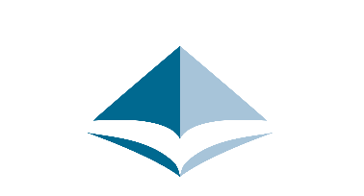
AALS Section Award Reimbursement Form

Please fill out the following form to request reimbursement for Section Awards no later than February 18, 2022. *Note: AALS is not issuing checks during the pandemic while we work remotely. For AALS to issue any payment we require all the following information. Once completed, please email the form and receipts to sections@aals.org.

Section Name
Section Award
Date
Payee
Street Address
City/State/Zip
Phone #
Dollar Amount | Subaccount | Dollar Amt |  |  | Purpose/GL Account #
 | [Internal Use] |  |  |  | [Internal Use]
 | TOTAL
Banking Instructions
Bank Name | Bank routing # |  |  | Account # |  |  | Recipient email:

*Please be sure to attach receipts.

