Letter from Outgoing Education Law Section Chair, Aaron Tang
Dear Colleagues:
It was another successful year for the Education Law Section. Our main section program, The Future of Affirmative Action, was well attended and featured a lively debate among an incredibly thoughtful and brilliant set of scholars, including Gail Heriot, Yuvraj Joshi, Kimberly Robinson, and Ben Trachtenberg. Several excellent questions were asked during the audience Q&A, and I believe all participants left the program with a greater understanding of the complexities of the affirmative action debate moving forward.
Professor Kimberly Robinson speaks during “The Future of Affirmative Action,” the Education Law Section’s main program.
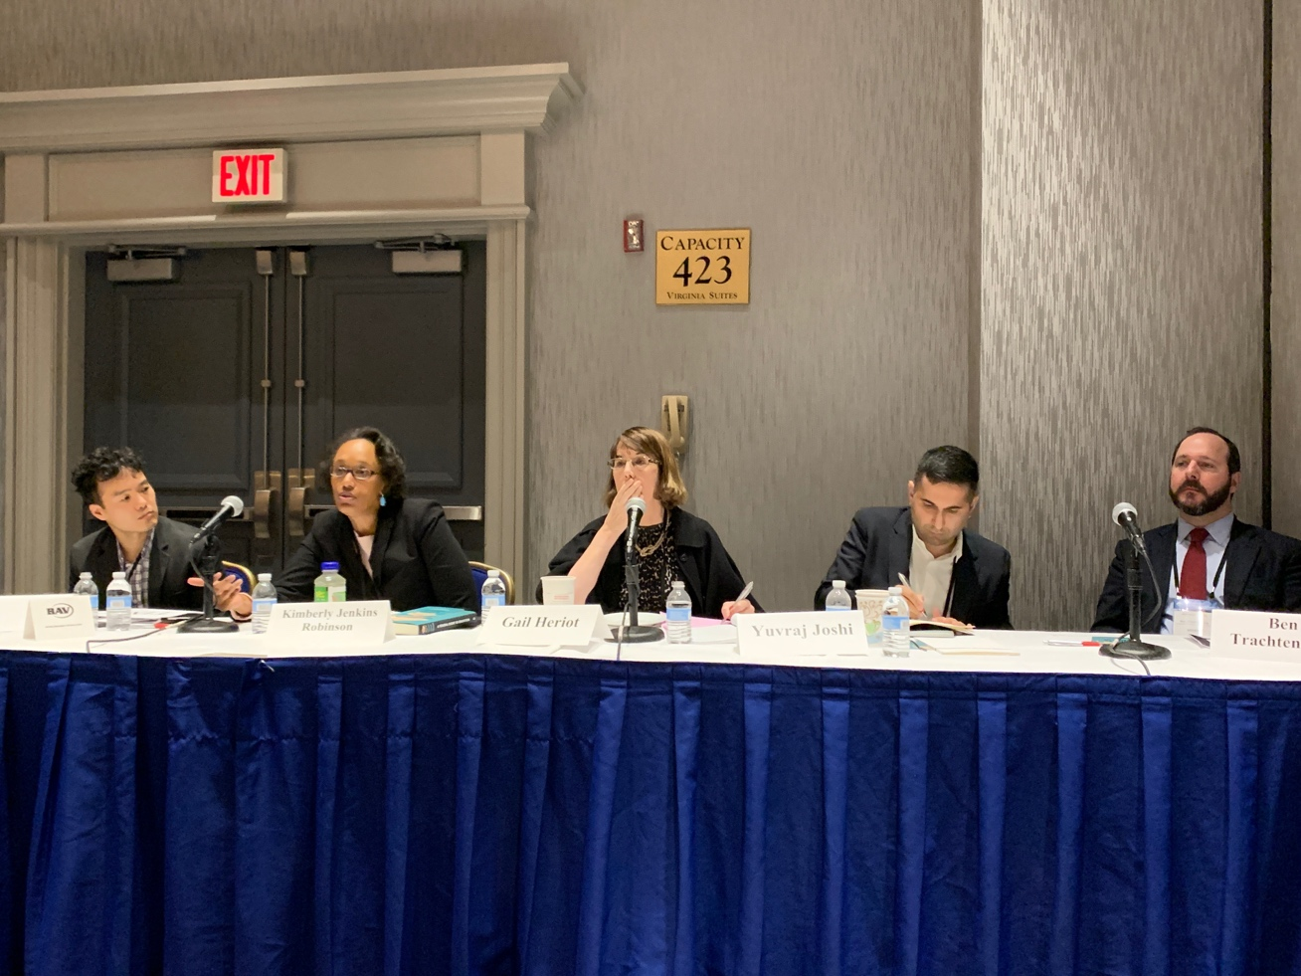
We also held elections for a new Treasurer and Treasurer-Elect. Congratulations to Natalie Gomez-Velez, Professor of Law at the City University of New York, who was elected Treasurer, and Miranda Johnson, Clinical Professor of Law at the Loyola University of Chicago School of Law, who will fill the role of Treasurer in 2021. They join our current slate of officers who will lead the section in the coming year: Maryam Ahranjani from the University of New Mexico School of Law, who will serve as Chair; Rochelle Newton from Duke Law School, who will serve as Chair-Elect; and Erin Archerd from the University of Detroit-Mercy School of Law, who will serve as Secretary.
It’s been an honor to serve as the section Chair this year, and I look forward to another wonderful program at next year’s meeting in San Francisco!

Warmest Regards,
Aaron Tang
University of California, Davis School of Law

Professional Updates from Section Members
This year’s presenters include Professor Emily Gold Walden, from Pace University, as an associate dean at the Elisabeth Haub School of Law. Professor Walden will participate in the Virginia Law Review Online Symposium, "Speech Inside the Schoolhouse Gates: Fifty Years After Tinker v. Des Moines" later this month. Her recent and forthcoming publications include 1. School Jurisdiction Over Online Speech, Oxford Handbook of United States K-12 Education Law (forthcoming 2020) (book chapter) (Kristi Bowman, ed.). 2. Title IX and Menstruation, Harvard J. Law & Gender (forthcoming 2020) (symposium issue) (with Margaret Johnson & Bridget J. Crawford). 3. Ministerial Magic: Tax-Free Housing and Religious Employers, 21 U. Pa. J. Const. L. Online (2019) (with Bridget J. Crawford). 4. Inclusion Riders and Diversity Mandates, 6 Belmont L. Rev. 229 (2019) (symposium issue). 5. The Unconstitutional Tampon Tax, 53 ​Richmond L. Rev. 439 (2019). 6. The Ground on Which We All Stand: A Conversation about Menstrual Equity Law and Activism, 26 Mich. J. Gender & Law (forthcoming 2020) (with Bridget J. Crawford, Margaret E. Johnson, Marcy L. Karvin, & Laura Strausfeld).
Professor Kimberly Robinson joined the UVA Law School faculty in the fall of 2019. She is the Elizabeth D. and Richard A. Merrill Professor of Law and Professor of Education, Curry School of Education. This year she published with NYU Press A Federal Right to Education: Fundamental Questions for Our Democracy (Kimberly Jenkins Robinson ed. 2019).
Aaron Saiger, (unable to attend this year’s AALS Conference), has some new education law work published since the last newsletter: Deconstitutionalizing Dewey, 13 Fla. Int’l. U. L. Rev. 765 (2019); The Tactics of Title IX, 13 Journal of School Choice 438 (2019) (reviewing R. Shep Melnick, The Transformation of Title IX: Regulating Gender Equality in Education (2018); and Unbundling School, 5 Education Law and Policy Rev. 1 (2019). I am deeply grateful to all the section members who supported me through my recent illness. I began to work full time again this year and am focusing on my book project on the law and online K-12 schooling (Schoolhouse in the Cloud, forthcoming Oxford UP).
Miranda Johnson, Clinical Professor of Law Director, Education Law and Policy Institute of Loyola University Chicago School of Law, highlights her work with James Naughton, Just Another School?: The Need to Strengthen Legal Protections for Students Facing Disciplinary Transfers. Notre Dame Journal of Law, Ethics and Public Policy, Vol. 33 Issue No. 1 (2019). Her other work includes Commentary: Limiting use of school ‘quiet rooms’ is not enough. Teachers need training and support., Chicago Tribune (Dec. 11, 2019) and Jackie Ross, Miranda Johnson, B. Alvarez, and Theodore Gelderman, A Place for Bullying Protections in School Lawyering, American Bar Association Children’s Rights Litigation Committee (Winter 2020),
Kristine (Kristi) Bowman, a Professor of Law and Education Policy at Michigan State University, has also become Associate Dean for Academic Affairs in the College of Education. This past year, she published: States’ Intervention in School Districts’ Finances (with Dirk Zuschlag) (research brief, National Education Policy Center, 2019). The Inadequate Right to Education: A Case Study of Obstacles to State Protection of a Right to Education, book chapter in KIMBERLY JENKINS ROBINSON, ED., THOUGHTS ON A FEDERAL RIGHT TO EDUCATION (2019, New York Univ. Press).
Eighty Years of Students’ Free Speech, book chapter in KRISTINE L. BOWMAN, ED., THE OXFORD HANDBOOK OF EDUCATION LAW (Oxford University Press) (online publication 2019, print publication expected 2020). She was also on sabbatical for six months at the University of Queensland in the School of Political Science and International Studies, and the School of Law. She also wrote a book she wished would have been available when she started planning a sabbatical abroad for her family: Modern Sabbatical: A Step-by-Step Guide to Moving Temporarily to Another City or Country, which is available on Amazon.
John E. Rumel, Professor of Law at the University of Idaho College of Law, is unable to attend this year’s AALS Conference. However, he wants to continue to serve on the Education Section’s Executive Committee for another year. His presentations include Statewide and Local Teacher Strikes Since Spring 2018 – A Comparative Analysis, Concurrent Session Paper Presentation, 2019 Education Law Association Annual Conference, November 13-15, 2019, Norfolk, VA. Potpourri from the Faculty -- Civil Cases Decided by the Idaho Supreme Court in the Last Year (or so), Continuing Legal Education Presentation, Presenter, 2019 Idaho State Bar Annual Meeting, July 26, 2019, Boise, ID (no paper). Admissibility of Opinion Evidence – Lay Witnesses and Experts, Presentation at the Idaho Trial Lawyers Association, Spring Seminar, February 22, 2019, Boise, ID (no paper). Amicus Brief: Drafted Amicus Curiae Brief for National Whistleblower Center in support of plaintiff in public sector employee whistleblower case, Eller v. Idaho State Police, Idaho Supreme Court, 165 Idaho 147, 443 P.3d 161 (May 24, 2019).
Susan L. DeJarnatt, Professor of Law Temple University Beasley School of Law, is unable to attend this year’s AALS Conference. Her published works are two education-related articles this year. Oversight, Charter Schools, and a Thorough and Efficient System of Public Education, 70 S. Carolina L. Rev. 435 (2018) and A Legal Mandate that Authorizers Consider Fiscal and Other Impacts of Charter School Expansion, 121 W. Virginia L. Rev. 811 (2019).
Aaron Tang, Acting Professor of Law at the University of California-Davis School of Law, had an enjoyable year serving as the AALS Education Law Section Chair. He had one education-related article accepted for publication, a co-authored paper entitled How Do Judges Decide School Finance Cases, forthcoming in the Washington University Law Review and online at https://papers.ssrn.com/sol3/papers.cfm?abstract_id=3350614.

Maryam Ahranjani, Associate Professor and Don L. & Mabel F. Dickason Professor at the University of New Mexico School of Law was awarded the Steven S. Goldberg Award for Outstanding Scholarship at the Education Law Association’s 65th Annual Conference in Norfolk for her articles The Prisonization of America’s Public Schools, 45 Hofstra Law Rev. 1097 (2017) and Universities as Sanctuaries, 44 J.C. & U.L. 1 (2018).

Remarks from Incoming Education Law Section Chair, Maryam Ahranjani

Dear Colleagues,

It is an honor to follow in the footsteps of our dynamic, outgoing Chair, Aaron Tang. Aaron has displayed incredible leadership over the past year, organizing and moderating an excellent program in Washington, DC. His incredible organizational skills and tireless work ethic will be missed, though he has generously agreed to serve on the Executive Committee to help keep the section vibrant as ever.

I look forward to working with incoming officers Rochelle Newton (Chair-elect), Erin Archerd (Secretary), and Natalie Gomez-Velez (Treasurer) as well as our talented Executive Committee to plan our programs for the 2021 AALS Conference in San Francisco. A number of terrific ideas were presented during the business meeting in DC, but please do feel free to send additional thoughts on a topic for our main section program (or any Hot Topics or discussion groups) so that we can consider them!

Here’s wishing everyone a happy, healthy, and rewarding 2020,

Maryam Ahranjani
Chair, Education Law Section, 2020

