AALS CLINICAL SECTION NEWSLETTER

FALL 2021
In This Issue
Page 1: From the Clinical Section Chairs
Page 2: Program Updates
Page 15: Committee Announcements
Page 16: Honors, Accolades, and Victories
Page 17: Upcoming Meetings and Conferences

Welcome to the Fall 2021 AALS Clinical Section Newsletter. We, your editors, are pleased to bring you exciting information and updates from both the Section and from schools and programs around the country.

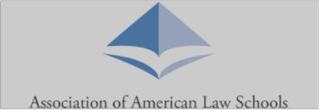

From the Clinical Section Chairs
For us, and we suspect for many of you, 2020 felt like the world's longest year, and 2021 has gone by in a flash. As our year of co-chairing the Clinical Section draws to a close, we appreciate the moment to stop and look back, because as always, there is so much to collectively celebrate when we take the time to look.

Our Section continued its focus on racial justice this year, and so many section committees rose to the occasion to re-orient existing programming and to develop new work to keep racial justice in the foreground of our minds and our work. To highlight a few:

- Our Teaching Methodologies Committee held seminars on Teaching Anti-Racism, and we are grateful to co-chairs C. Benjie Louis (Hofstra) and Jean Phillips (Kansas), and committee members Samir Hanna (Harvard), Kendall Kerew (Georgia State), and Paul Radvany (Fordham).

- Our Policy Committee, together with CLEA's Committee for Faculty Equity and Inclusion, published the report Best Practices for Hiring and Retention of Diverse Clinical Faculty with CLEA, a report on diversity hiring for clinical which will be shared soon – and which will be the focus of our Section’s January program at the main AALS conference. The dream team comprised AALS Committee members Caitlin Barry (Villanova), Lisa Bliss (Georgia State), Vida Johnson (Georgetown), Carolyn Kaas (Quinnipiac), Kele Stewart (Miami), and Erika Wilson (North Carolina); CLEA committee members : Priya Baskaran (WCL), Jennifer Fernandez (Penn), Crystal Grant (Duke), Anju Gupta (Rutgers), Julia Hernandez (CUNY), Alexis Karteron (Rutgers), Shobha Mahadev (Northwestern); and Lynnise Pantin (Columbia) and Gautam Hans (Vanderbilt/Jeopardy) who were on both committees.

- Our Externship Committee, led by Nira Geevargis (UC Hastings) and Amanda Rivas (St. Mary’s Texas), has embraced this work through, among other things, its Racial Justice Facilitated Discussion Project, which held a series of events led by Shilpa Jain, Executive Director, YES!, Connecting, Inspiring & Collaborating with Young and Intergenerational Changemakers. The workshops proceeded in several parts: intensive, multi-session, small-group, deep work; a session designed afterwards to best meet the ideas of the participants based on the individual and collective experience; and synthesis.

- And last but never least, our brand-new Racial Justice committee formed, chaired by Daniel Harawa (Washington U) with Anita Sinha (WCL), Heather Abraham (Buffalo), Susan Chase (New York Law School), Katy Dyer (Texas), Llezlie Greene (WCL), Reena Parikh (Boston College), Mridula Raman (Berkeley), Gus Tupper (Berkeley). They spearheaded the submission of multiple racial justice and anti-racism proposals for the 2022 Clinical Conference—stay tuned for those!

And of course, all this comes in addition to the work so many clinics do to address individual and systemic injustices. When eviction moratoria began to expire this spring, it was no surprise to us that clinicians like Norrinda Hayat (Rutgers), Michele Gilman (Baltimore), Kathryn Sabbeth (UNC) and so many more were at the forefront of the response.

Which comes to the message we want to convey. Each of us in our own clinics, and even at schools where we have tremendous, collaborative, creative colleagues who inspire us, feels like what we do is never enough. And of course, when we consider what feels like an ever-increasing set of barriers to justice, nothing is enough. But the joy of the year we have spent chairing the Executive Committee is understanding in specific, concrete, and immeasurable ways how far our work goes collectively. The work you all do makes a difference for our clients, for our communities, and so enduringly, for the students who go forth and carry on the good, necessary work. We see what you all do, and we draw strength from it. We hope you will get glimpses of that reading and delighting in each other’s accomplishments in this newsletter—where will end with two more names in bold, to say thank you to our newsletter editors Dena R. Bauman (UC Davis) and Keeshea Turner-Roberts (Howard).

With hope and gratitude,

Liz and Fatma

Friends,
Liz Keyes & Fatma Marouf, Section Co-Chairs

Program Updates

American University Washington College of Law
Students in the AUWCL Criminal Justice Clinic (CJC) continue the fight to gain the release of prisoners, many of whom are elderly or ill, who are serving unjustly long sentences in the Federal Bureau of Prisons and the Maryland Department of Corrections. In 2020-2021, CJC student-attorneys secured the release of eight clients, and current CJC students are continuing to seek relief for clients under the DC Compassionate Release Act and Maryland's newly-enacted Juvenile Restoration Act. CJC continues to work with many clients after they are released as they grapple with the myriad difficulties of reentering society after spending many decades locked up.

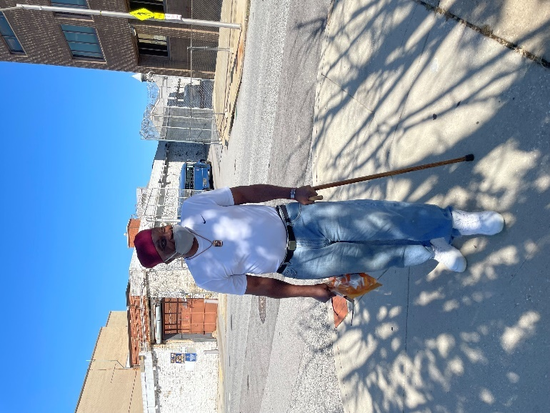
Picture of a client (“JB”), who was finally paroled by Maryland at age 71 for a life sentence he received for an offense he committed as a minor.

AUWCL’s International Human Rights Law Clinic student attorneys are engaged in two new projects related to environmental justice. The first is with Minority Rights Group International to shed light on the flaws in the United Nation’s Post-2020 Global Biodiversity Framework, which calls for 30% of Earth’s land and sea areas to be under conservation by 2030. The other project is a collaboration with EarthJustice to advance its advocacy exposing migration detention facilities built and/or operated on toxic sites.

Boston University School of Law
Students in the BU Law Immigrants’ Rights and Human Trafficking Program, in collaboration with local attorneys, legislators, and advocates, oversaw the passage of state legislation to improve government responses and policies for immigrant survivors of crime. The legislation, Certification for Victims of Violent Crime and Human Trafficking, requires that state and local certifying governmental agencies issue a policy for U and T visa certification for immigrant survivors, and they respond to requests for certification within 90 days. Clinic students are now working to monitor implementation efforts and train governmental agencies about the law.

Columbia Law School
In December, Columbia Law School’s Lawyering in the Digital Age Clinic, directed by Professor Conrad Johnson, co-sponsored a virtual Statewide Foreclosure Summit. The Summit brought together representatives of municipalities from across New York State with a goal to assist them in meeting the challenges of the impending mortgage foreclosure crisis. Clinic students made a presentation as part of the Summit and unveiled a new, free, online resource to help municipalities deal with the crisis.

The Summit built upon a very successful initiative that the Clinic engaged in with the Erie County Clerk and the Western New York Law Center (WNYLC), both of whom were partners in the Summit. In that initiative, the Clinic worked with the WNYLC and the Erie County Clerk to create an online portal through which law students, under the supervision of the WNYLC, use data provided by the County Clerk to identify the mortgage servicers who are responsible for the upkeep of vacant “zombie” properties the servicers obtained through foreclosure. Through this innovative collaboration, Erie County communities receive the benefit of painstaking legal services to remedy the blighting influence of these properties.

Florida State University College of Law
The FSU Public Interest Law Center educates the community about the history of lynching in North Florida. Through partnership with the Tallahassee Community Remembrance Project, the Center developed curriculum for the Leon County School District on lynching and helped to erect a memorial plaque honoring victims of lynching: Pierce Taylor, Mick Morris, Richard Hawkins, and Ernest Ponder.

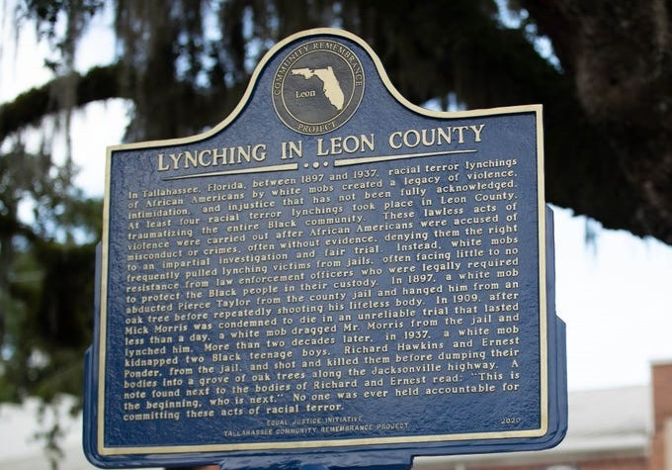

The FSU Public Interest Law Center is excited to announce a new clinic in Spring 2022. The International Human Rights Advocacy Clinic, directed by Clinical Professor Darby Kerrigan Scott, will provide students with hands-on experience representing individual human rights survivors and international non-governmental organizations engaged in human rights advocacy. Students will gain experience in areas including evidence collection, research reports, litigation, amicus briefs, UN standard setting, and norm development.

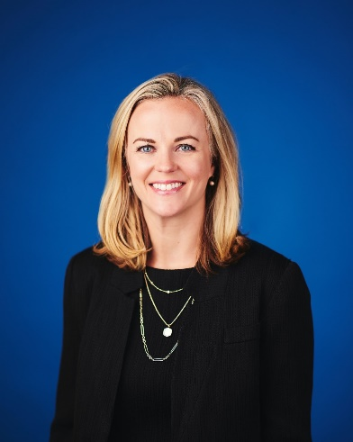
Professor Darby Kerrigan Scott

Also, FSU’s Farmworker & Immigration Rights Clinic enters a new chapter under the direction of Professor Ashley Hamill. The Clinic fills a substantial gap in services in North Florida as the only organization providing free holistic deportation defense. The Clinic’s work supports community members in their struggle to come out of the economic shadows and assert their rights to immigration status, employment authorization, and protection from violence and persecution. On behalf of a father and his young son separated by ICE at the Southern Border, students submitted a Public Comment on proposed federal rulemaking that would deprive asylum seekers of full and fair evidentiary hearings.

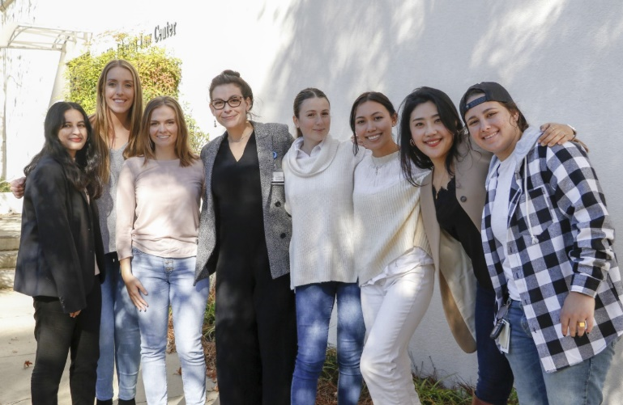
Professor Ashley Hamill and Students

The FSU Children in Prison Project, directed by Prof. Paolo Annino, had a major victory! Kenneth Young was 15 years old when he received four
consecutive life without parole sentences. The Children in Prison Project has been advocating for Kenneth for 12 years. A documentary entitled 15-to-Life memorializes Kenneth’s Story. Kenneth was released from prison on July 1, 2021

Fordham Law School
We are proud to announce two new Programmatic Collaborations and Developments:

The Parole Information Project is leading the charge against the crisis of mass incarceration in this country, using innovative ways to turn the tide against a parole system that is broken and overwhelmingly punishes people of color. Professor Martha Rayner and her students in the Criminal Defense Clinic, are attacking the problem from the back end, by untangling New York State's parole system.

The Parole Information Project is a unique data base of parole documents, that aims to make the archaic, Byzantine parole and parole appeal process easier to navigate and more transparent. Not many people, especially new lawyers, know that information about an incarcerated person's parole record is virtually impossible to obtain.
Getting the data alone was not enough. There was clearly an access to justice issue -- parole applicants who had been denied needed representation. So Rayner collaborated with Michelle Lewin from The Parole Preparation Project to recruit and train pro bono lawyers at law firms in the parole appeals process. Prior to this, students in the Criminal Defense Clinic, under the supervision of Martha Rayner and Cheryl Bader, handled such cases.

Georgetown Law
Spring 2022 will mark the inaugural semester of Georgetown Law’s newest clinic, the Racial Equity in Education Law and Policy Clinic. Professor Janel George, the founding director of the Clinic, joined the Law Center earlier this year as a tenure track faculty member. Professor George’s clinical projects and scholarship focus on the development and implementation of legislative interventions to advance racial equity in education at the local, state, and federal levels, and she brings with her a wealth of experience in legislative law and policy advocacy.
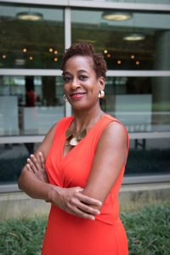
Professor Janel George
The Clinic will partner with selected clients whose work involves advancing racial equity in education, including nationally focused organizations, smaller local groups and student-led organizations. Students will employ a number of policy strategies to address clients’ priorities, including legal and legislative research, analysis, and drafting, public education, coalition-building, community education, and oral and written advocacy.

Juvenile Justice Clinic Director Kristin Henning has published her new book, “The Rage of Innocence: How America Criminalizes Black Youth.” In the riveting piece, Professor Henning writes about her 26 years defending Black children prosecuted for offenses including “horseplay” on the Metro, throwing snowballs at a passing police car and playing catch with a teacher’s hat. Her book takes a deep dive into adolescent psychology, the racially disparate responses to normal teenage behavior, and the trauma over-policing creates for Black youth. She also explores dehumanizing practices such as shackling; traces the roots of school-based policing to civil rights protests, not Columbine; and celebrates the resilience of Black youth captured in trends like #BlackGirlMagic and #BlackBoyJoy.

Professor Henning served as a public defender in Washington, D.C. before joining the Georgetown Law faculty in 2001 to teach in, then lead, and then expand the Juvenile Justice Clinic and Initiative.

Director Kristin Henning

Golden Gate University School of Law
Women’s Employment Rights Clinic (WERC)
When the pandemic hit, WERC pivoted immediately to focus our attention on the impact of the pandemic on low-wage workers. In the last year, WERC students recouped $478,000 for low wage workers. We not only provided direct legal services to workers who needed help with unemployment insurance and understanding their workplace rights, but we also took on an array of statewide advocacy.
With a broad coalition of worker advocates and unions, our clinic spearheaded advocacy before the Employment Development Department, to force them to streamline their process for app-based drivers who are misclassified. We helped hundreds of Uber/Lyft workers secure benefits and drafted an advocacy letter outlining the problems with EDD’s handling of app-based drivers’ benefits claims. We also spearheaded a statewide advocacy effort to get the state of California to create a disaster relief fund for undocumented workers, who are not eligible for unemployment insurance. Two weeks after our advocacy letter, Governor Newsom announced the $75 million disaster relief funds for this community.

The Clinic, as legal counsel to the California Domestic Worker’s Coalition, drafted SB 321: The Health and Safety for All Workers Act. California wildfires already were endangering the health of domestic workers whose employers required them to enter evacuation zones, protect animals and/or clean up after the fires. The pandemic increased the health and safety risks for domestic workers. But despite the unprecedented hazards for domestic workers, they remained excluded from health and safety protection. SB 321 will establish the first set of guidelines for health and safety in the domestic work industry in the state's history and it makes recommendations on how to expand health and safety coverage for domestic workers. It was signed into law on September 27, 2021.

Harvard Law School
The Harvard Representation Initiative, which offers free immigration and social work services to the Harvard community, published an issue brief, Lessons from the Harvard Representation Initiative: A Holistic Approach to Immigration Representation, in collaboration with the Harvard Immigration Initiative.

The Food Law and Policy Clinic (FLPC) is building on its research for The Global Food Donation Policy Atlas. This fall, FLPC published three issue briefs on laws and policies that impact food donation, including policy addressing food donation operations amid COVID-19, tax law and policy, and food date labeling law and policy. Each brief highlights best practices in countries around the world and is accompanied by a virtual discussion of government leaders who share experiences in exploring and implementing food donation policies in their country.

A federal judge ruled that the Animal Law & Policy Clinic’s lawsuit against the USDA for failing to require humane handling of poultry at slaughter must move forward.

Following a lawsuit filed by the Election Law Clinic, Governor Ron DeSantis called special elections for three majority-Black legislative districts, to be held in early 2022.

Harvard Negotiation & Mediation Clinical Program is proud to be part of the dispute resolution team at Harvard Law School, which U.S. News and World Report ranked #1 in Dispute Resolution Programs for the second year in a row.

Loyola University, New Orleans
The Stuart H. Smith Law Clinic and Center for Social Justice at Loyola New Orleans is offering eight law clinic sections for the 2021-22 academic year and enrolled over 80 law student practitioners. This year, the Law Clinic added several new projects. The United for Early Childhood Education Centers Project provides legal support and technical assistance to early childhood centers with accessing Payroll Protection Program (PPP) funds. The PPP funds enable early childhood education facilities to remain operational by helping them retain and pay their staff and thus, give more children access to quality early education. With support from our legal team, over $3.5 million has been forgiven thus far. The Reentry Project supports incarcerated and recently released individuals on a variety of legal issues such as traffic, custody, misdemeanor attachments, divorce and child support in an effort to help clients successfully reenter the community. Following Hurricane Ida, the Law Clinic launched the Disaster Lawyering Project to provide legal support on FEMA issues following Hurricane Ida.

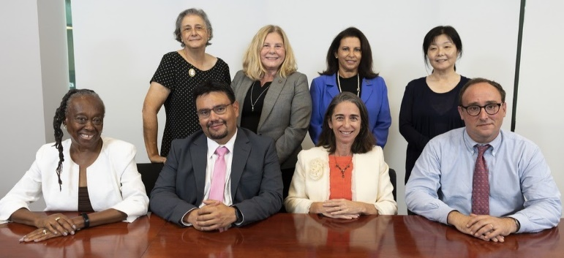
Loyola New Orleans Law Clinic Faculty
Back Row: Luz Molina, Cheryl Buchert, Ramona Fernandez, Hiroko Kusuda
Front Row: Majeeda Snead, Hector Linares, Davida Finger, Judson Mitchell

Northeastern University School of Law
During the pandemic, the Immigrant Justice Clinic, has transitioned much of our work. We have been partnering with non-profit organizations at the US-Mexico border. Specifically, we have partnered with Lawyers for Good Government’s Proyecto Corazon, assisting asylum seekers in Matamoros, and Al Otro Lado, working with indigent migrants in Tijuana. With Proyecto Corazon, students focused on a long-term project preparing complete asylum applications for individuals who had fled their homes in Central America and found themselves stuck in the Matamoros tent encampment where asylum-seekers waited to be allowed to cross the closed border.
With Al Otro Lado, students completed weekly half-day intake shifts with indigent clients in Tijuana. These shifts allowed students to engage with clients from a variety of circumstances and with a variety of needs to assess their ability for legal relief, as well as the wraparound services provided local organizations. Taking the remote learning setting as an opportunity to pivot the kind of work the clinic usually does, students assisted these organizations in meeting overwhelming need brought about by the dual crises of the pandemic and at the border.

Penn State Law
Two law students argued for Penn State Law’s Civil Rights Appellate Clinic before the Third Circuit in Mondelli, 1 F.4th 145 (June 15, 2021), for a client with severe intellectual disabilities, who sued his nursing home, creating important precedent to help other older individuals who are mistreated or denied services.

Penn State Law’s Entrepreneur Assistance Clinic started the Underserved Small Business Legal Services Program to assist USBs with obtaining government and corporate program benefits, the Center for Immigrants' Rights Clinic created Biden administration immigration change resource pages, and the Indigent Criminal Justice Practicum started a local Pardon Project.

Rutgers Law School
Thanks to more than $2 million in state grants to confront the looming eviction crisis, Rutgers Law School clinical faculty launched Anti-Eviction/Eviction Diversion Projects on each campus, in coordination with colleagues at Seton Hall. The efforts include new hiring, expanded clinic seats for students, new pro bono and community-based projects, as well as funding for post-graduate and student fellowships.

The Rutgers Federal Tax Clinic celebrated its 25th year of serving low-income individuals with income tax disputes. The Clinic was lauded for its efforts by the Taxpayer Advocate Service of the IRS, for its dedication to serving an underserved community and for providing education and outreach to low-income communities about their taxpayers’ rights and responsibilities. The Clinic continues to be successful is assisting low-income immigrant in many capacities, such as advising them of their rights to income tax credits and benefits as well as proving “good standing” for immigrants being held in detention for minor criminal infractions.

With the support of a grant from Arnold Ventures, the Rutgers Criminal and Youth Justice Clinic launched its Juvenile Fines and Fees Elimination Project earlier this year. Building on its successful 2020 campaign that prospectively eliminated most monetary penalties imposed on youth in New Jersey, the Clinic, in partnership with a coalition of abolition advocates, spearheaded the introduction of a bill that would repeal those sanctions not captured in the previous legislation and rescind all previously imposed, still unpaid fines and fees. Fingers crossed for swift passage!

Saint Louis University School of Law
In recent years, the work of the Criminal Defense Clinic (directed by Professor Susan McGraugh) has evolved to encompass sentencing mitigation advocacy. As one of the few clinics in the country to employ a full-time forensic social worker (Professor Lauren Choate), the clinic is uniquely positioned to work on these kinds of cases. Using what they have learned in their clinic work, Professors McGraugh and Choate launched an interdisciplinary sentencing mitigation course with the College for Public Health and Social Justice open to both law and social work students. They hope this course can become a model for the emerging field of sentencing mitigation education.

The classroom component of the Judicial Field Placement Program (directed by Professor Megan Phillips and Professor Retired Judge Lisa Van Amburg) has evolved to include timely topics highly relevant to students. For example, the course includes a greater focus on mental health as a professional priority as well as more in-depth exploration of access-to-justice challenges for indigent and incarcerated litigants. Professors Phillips and Van Amburg use engaging guest speakers with direct experience on these topics, each of whom brings a compelling and relevant perspective. As a result, students are equipped to connect their individual judicial experiences with their classroom learning and to engage in deeper reflection and self-assessment.

St. Mary’s University School of Law
In June 2021, the St. Mary’s University School of Law Clinics returned to in-person operations – with protocols in place to do so as safely as possible.

Ongoing visitation restrictions at detention centers continue to curtail the ability of our Immigration and Human Rights Clinic to represent detained clients. And severe hearing delays continue for non-detained cases. To maximize the impact we can make while these constraints persist, we have increased our caseload of affirmative cases including VAWA, T visa, and U visa applications for crime victims.

Our Family Law Clinic serves as amicus attorneys representing the best interests of the children in divorce and custody cases. With these hearings still held by Zoom, students are learning to navigate that practice, likely to continue for some matters even post-pandemic. The Family Law Clinic also prepares wills, prioritizing cases for clients in end-stages of life. To minimize health risks, the Clinic has perfected a system of drive-up will executions.
In our county, in-person jury trials have resumed, and our Criminal Justice Clinic is working on multiple upcoming cases. Recently, after extensive hours of research on pretrial issues and trial preparation, students won a not guilty verdict in a jury trial.
Our Consumer Protection Clinic continues to operate our Housing Hotline created in response to the pandemic. The Hotline provides callers remote consultations with our attorneys and law students and referrals to other resources – assisting over 1500 callers to date. Our Clinic also takes on Hotline cases for extended representation, ranging from evictions to complex seller-financed transactions.

In a related project, St. Mary’s recently hosted a utility, rental, and legal assistance event, co-sponsored by the offices of two City Council Members. On one day, over 400 San Antonians came to our campus for assistance. St. Mary’s faculty, staff, and students helped residents navigate legal questions and connected them to critical rental and utility assistance resources.

SMU Dedman School of Law
SMU’s Child Advocacy Clinic’s podcast “Aged Out-The Stories that Built Us” was recently featured as one of Feedspot’s Top 15 Child Welfare Podcasts. The Clinic will also be hosting a Child Psychiatrist Fellow, from the post-graduate Fellowship Program at the UT Southwestern Medical School, beginning in the spring 2022 semester.
Suffolk University Law School
Our clinical programs welcomed our students and faculty back onto campus after more than a year of virtual clinics. Our 12 in-house clinics have adapted to the new, hybrid reality of practice and learning with creativity and a commitment to meeting the evolving needs of our clients and students. We are simultaneously invested in improving the diversity, equity and inclusivity of our programs. To that effect, our faculty and staff devoted our full-day clinical retreat this fall to DEI issues, identifying concrete plans for our individual clinics and our program as a whole, which we intend to work through in the coming year and beyond. In addition, several of our clinics have taken on new kinds of legal work, as well as new approaches to existing work. For example, students in our Health Law Clinic are working to reform adult guardianship practice in Massachusetts through a combination of Probate Court advocacy, crafting Supported Decision-Making Agreements for persons with intellectual disabilities, and conducting virtual workshops on limitations and alternatives to guardianship. Students in our Immigration Clinic are assisting Haitian refugees by providing assistance with applications for Temporary Protected Status, while students in our Prosecutors Program are working on a juvenile diversion initiative. Our Housing Discrimination Testing Program has received new grant funding from several sources to support expanded undercover discrimination testing and enforcement, as well as new funding from the American Rescue Plan to launch fair housing outreach and housing search services. Our Legal Innovation and Technology Lab (LITLab) has continued to revolutionize digital access to legal help through its Court Forms Online project. The LIT Lab looks forward to hosting its first hybrid LITCon this coming spring. Please look out for dates and registration information this winter!

Texas A&M University
We added a new Environmental & Natural Resources Systems Legal Clinic for the spring semester. Professor Gabriel Eckstein and Local Attorney and adjunct, Professor Sara Thornton, will teach the new clinic. Clinic students will represent and work with various entities to address local, state, and federal concerns related to the use, conservation, management, and protection of land, water, air, the environment, habitats, species, and other natural resources.

The Immigrant Rights Clinic filed a civil rights complaint with the DHS Office of the Inspector General and the DHS Office for Civil Rights and Civil Liberties about the use of a full-body restraint device called "The WRAP" on African asylum seekers before and during deportation flights.

Tulane University Law School
Tulane Law School’s Civil Rights and Federal Practice Clinic continues to expand its work in combatting unlawful police brutality. On October 15, 2021, the clinic filed a petition for a writ of certiorari in Tucker v. City of Shreveport, et al., asking that the United States Supreme Court to resolve the Fifth Circuit’s disregard for the Court’s long-held obviousness principle of qualified immunity and to resolve the dispute over proper application of qualified immunity.
“Tulane’s Immigrant Rights Clinic has developed two new community programs. IJC Fellow Gaby Cruz is representing immigrant youth through a collaboration with ALAS, a local partner advocating for educational access. This Spring, clinic students are developing a community-based clinic in collaboration with national and local Haitian community leaders to assist Haitians applying for temporary protected status.”
With the opening of Louisiana prisons after COVID closures, the Tulane Women’s Prison Project, a collaboration between the Criminal Justice Clinic and the Domestic Violence Clinic, has begun work on a delayed project developing a training program, materials, and resources, focused on the needs of incarcerated survivors of intimate partner violence seeking post-conviction, clemency, parole and habeas relief.

University of Detroit Mercy School of Law
Detroit Mercy Law has launched our new Conviction Integrity Clinic. Working in partnership with the Wayne County Prosecutor's Office Conviction Integrity Unit (CIU), the clinic assists wrongfully convicted individuals. The clinic investigates claims of innocence to determine whether there is clear and convincing new evidence that the convicted defendant was not the person who committed the offense. The Wayne County office has an ever-increasing backlog of applicants seeking consideration for exoneration. The underlying police and court files must be carefully reviewed, a process that takes a year per application on average. The clinic students will provide CIU with a minimum of 2,500 hours annually. Students learn the practical aspects of prosecution and the process of the CIU. Clinic students review petitions for relief, the case files, police reports, trial transcripts, and pleadings. Students interview witnesses who are identified as supporting the claim of innocence.

The Conviction Integrity Clinic is directed by Adjunct Professor and CIU Director Valerie Newman and supported by Assistant Wayne County Prosecutors. Professor Newman has received national recognition for her work as Director of CIU. Since 2018, twenty-nine individuals have been exonerated, who collectively spent more than 400 years wrongfully imprisoned.

UDC School of Law
UDC Law has adapted our clinical offerings to better meet the needs of our students enrolled in our robust evening program. This fall, we launched the “clinical semester” for our evening students. UDC Law evening students must engage in one of the school’s clinics for 10-credits in the Fall semester of their fourth year in order to graduate. Clinics will be offered to evening students on a rotating basis. This fall, Professors Tianna Gibbs and Andy Budzinski adapted their work in the General Practice Clinic to focus on providing unbundled legal services to litigants in family law cases to help them navigate the complexities of remote court operations and effectuating service of process during a global health pandemic. Professor Mae Quinn’s evening students in the Youth Justice Clinic have also been hard at work filing an amicus brief with the U.S. Supreme Court, engaging in advocacy around the right to vote in jail, and engaging in community-based legal education for incarcerated young people through Juris Libertas.

We are also thrilled to share that the Legislation/Civil Rights Clinic received DV LEAP’s 2021 Community Champion Award for legislative lawyering advocacy that addresses the impact of climate change on domestic violence in law and policy.

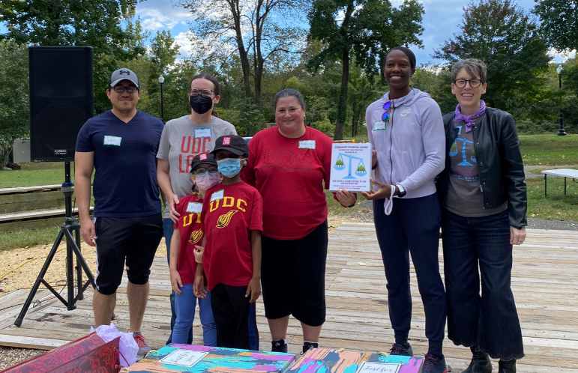
Photo of Professor Marcy Karin, Director of the Legislation & Civil Rights Clinic, center in red UDC Law t-shirt surrounded by UDC faculty, alums, and students.

Professor Jerome Hughes joined UDC Law to direct our Community Development Law Clinic in Fall 2021. We are thrilled to welcome Professor Hughes back as a faculty member after he served as a clinical instructor and fellow back in 2017-2018. We also welcomed Associate Dean for Academic Affairs, LaShanda T. Adams, back to the clinical faculty. She is currently leading a section of the General Practice Clinic focused on child welfare matters. Professor Lindsay M. Harris is currently serving as Associate Dean of Clinical and Experiential Programs and directing the Immigration and Human Rights Clinic.

UC Hastings
The UC Hastings Clinical Program has responded to the continuing pandemic with flexible protocols to service our client and student holistic needs. For instance, our Refugee and Human Rights Clinic (RHRC), directed by Professor Karen Musalo and Professor Christine Natoli, has represented their clients who are seeking asylum with a mix of both remote and in person representation tailored to the specific needs of each individual. The RHRC has continued to service hard-to-reach populations, including an indigenous Guatemalan woman who speaks the Mayan dialect, Mam. In addition, the Clinic's human rights docket, which previously involved fact-finding travel to Central America, has found creative ways to connect with in-country sources over Zoom. Students have been working with a Salvadoran children’s rights expert to develop her expert declaration in support of the many children who apply for asylum in the United States.

Our clinics have also been involved in cutting edge representation and policy issues. For example, in our Lawyering for Children Practicum at Legal Services for Children, two students have been engaged this semester in helping young people file their renewal DACA applications and also prepare initial applications to be ready in case the DACA rules change, as has been proposed recently by the Biden administration. These same two students are also drafting comments to the proposed rule, connecting their direct service work with policy advocacy.

Finally, our clinical professors from different disciplines recently worked together on an international academic exchange on clinical legal education and mediation. Professor Kate Bloch, who directs our Criminal Practice Clinic, and Professor Mai Linh Spencer, who directs our Individual Representation Clinic, co-chaired a virtual mediation workshop with UC Hastings and l’Ecole Supérieure Catholique de Droit de Jérémie, a Haitian law school that has a decades-long collaborative partnership with UC Hastings. The mediation workshop, in English and French, was held over Zoom in May 2021 and featured Mediation Clinic faculty, including Professor Betsy Candler, Professor Carol Izumi and Professor Gail Silverstein.

UC Irvine Experiential Education Program
We have continued to examine how to deepen our commitment to combatting anti-Blackness and fighting for racial justice in our teaching, practice and in our institutional roles. We held workshops in the spring and summer to exchange ideas and develop learning objectives. Our work parallels UCI Law’s adoption of a new requirement that students take at least one course on race and indigeneity before they graduate.

The new Workers, Law, and Organizing Clinic will focus on organizing essential workers forced to work under unsafe conditions during the pandemic. Clinic teams are currently working with an array of clients, including: day laborers, rideshare drivers, food processing, hospitality workers, meat packing workers, and worker cooperatives.

The Civil Rights Litigation Clinic obtained a grant of a petition for habeas corpus on behalf of a wrongfully convicted client who served 26 years in prison for a crime he did not commit. He was released from prison in September.

Since 2019, the Criminal Justice Clinic has successfully won the release of eleven individuals, including five of whom were serving life sentences and three who were serving “effective life” sentences. Many of these clients had each already served over 30 years in prison.

HBO’s "Last Week Tonight" recently featured a segment on the predatory nature of the Property Assessed Clean Energy Program. The Consumer Law Clinic contributed to the segment by sharing its expertise as well as client experiences.

California Governor Gavin Newsom recently signed into law a bill the Domestic Violence Clinic proposed on behalf of multiple clients to include reproductive coercion in California's definition of domestic abuse. California is the first state with such a law.

University of Houston Law Center
The University of Houston Law Center is pleased to announce the addition of two new clinical course offerings starting in the Spring 2022 semester: an Appellate Civil Rights Clinic taught by Professor Martin Siegel and an Entertainment Law Clinic taught by Professor Justen Barks and Professor Yocel Alonso.

Students in the Appellate Civil Rights Clinic will represent clients and amici in appeals of civil rights claims in federal and state courts. Appeals will include §1983 cases arising from law enforcement misconduct and unconstitutional prison conditions, cases alleging discrimination in employment and public accommodations, First Amendment speech and religion clause cases, and others.

The Entertainment Law Clinic is an advanced entertainment law course for students seeking practical experience in transactional and administrative aspects of the entertainment industry. Students will represent creators, businesses, and non-profits in the music, film and television, dance, and art businesses with a focus on trademark and copyright prosecution and counselling, contract drafting and negotiation, and royalty stream creation and retention.

University of Illinois, Chicago
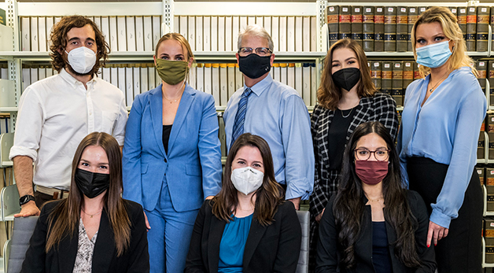
The Fair Housing Legal Clinic (FHC) at the University of Illinois Chicago had an eventful year as safe housing continued to be life and death. The Illinois State Bar Association (ISBA) recognized the clinic with the 2020-2021 ISBA LEAC Excellence in Legal Education Award. The Legal Education and Competence Committee (LEAC) selected the FHC for its longstanding commitment to teaching excellence. Also, the FHC was able to reduce student debt through the generosity of Baird & Warner, a Chicago based real estate firm that committed $215,000 to establish the John Baird Scholarship Fund to support law students dedicated to fair housing advocacy!

University of Maryland
The Mediation Clinic received the Alternative Dispute Resolution Program Award from the District Court of Maryland’s Office of Alternative Dispute Resolution in recognition of its 20 years of service. The clinic gets referrals through longstanding collaborations with the District Court ADR Program and District Court judges. The clinic also serves as the mediation program for the Baltimore City Community Relations Office of Civil Rights, mediating employment and discrimination cases, and works in K-12 Baltimore City schools to mediate student conflicts and train students to be peer mediators. The Mediation Clinic is taught by Professor Deborah Thompson Eisenberg and Clinical Law Instructor Toby Treem Guerin, with supervisory assistance from Anastasia Smith, Esq.

Our Eviction Prevention Project received a $75,000 grant from the Goldseker Foundation to hire a staff attorney to provide eviction defense services to clients in Baltimore City. The project, which is a collaboration between the Fair Housing, Public Health Law, Medical-Legal Partnership, and Mediation Clinics, along with the Law and Social Work Service Program, works to prevent evictions in Prince George’s County and Baltimore City. The Public Health Law, Fair Housing, and Medical-Legal Partnership clinics provide direct representation in court and participate in the policymaking process; the Mediation Clinic oversees partnership development with community mediation centers and training in alternative dispute resolution; and the Law and Social Work Service Program and social work field offices provide access to needed social services and supports to improve short-and long-term outcomes for families most impacted by the COVID-19 crisis. Professors Sara Gold (Medical-Legal Partnership), Thomas Silverstein (Fair Housing), Kathi Hoke & Kerri Lowrey (Public Health Law), and Toby Guerin (Mediation) have been leading this effort.

University of Miami
Miami Law Innocence Clinic won a stunning victory for clinic client Dustin Duty, securing his release from prison on October 27, 2021. The Innocence Clinic took on his case in 2016 after Duty wrote letters to the clinic asking for help. Over the past five years, at least 18 clinic students have worked jointly with the Innocence Project of Florida to represent him in his claims of innocence.

The Environmental Justice Clinic has partnered with People’s Environmental and Economic Resiliency (P.E.E.R) Group, a nonprofit law firm in Miami that is committed to sustainability and resiliency to help launch the Equitable Weatherization Clinic. The project focuses on creating equal opportunity for access to weatherization services in historically marginalized communities. Equitable weatherization is an opportunity to meet community needs by enhancing access to energy-efficient and resiliency improvements, particularly for households within marginalized communities subject to immense energy burdens that put both health and housing security at risk.

Miami Law’s Entertainment, Arts and Sports Law program launched the LegalArtLink practicum. Students in the course will gain practical legal experience by assisting artists with legal issues.

University of Tennessee
The University of Tennessee Legal Clinic has made exciting new programmatic changes. A new Transactional Legal Clinic (TLC) co-taught and designed by Professors Eric Amarante and Brian Krumm will teach our students transactional skills and improve the student experience by increasing viewpoint diversity in the clinic classroom.
Tennessee Clinic faculty with the help of our Masters in Social Work student enhanced our clinic-wide Wellness Curriculum by adding new reflection assignments, wellness plans for students, and check-ins by faculty supervisors. This curriculum challenges students in every clinic to develop strategies that focus on self-care as they confront the demands of their clinic cases.

The Transactional and the Mediation Clinics along with their community partner, the Knox County Community Mediation Center, are collaborating to offer conflict management and dispute resolution training and services to clinic clients and to develop dispute resolution clauses for business contracts.

University of Virginia
UVA Law Clinics have expanded in the last two years, reaching a total of 24 clinics. These clinics expand the reach of our clinical work into the community, with an emphasis on criminal justice and equity.

Students in the State and Local Government Policy Clinic, launched in Fall 2020, helped all of their state lawmaker clients, Democrats and Republicans, see their bills through to approval this year. Some of the legislation represented milestone changes in the state’s criminal justice system.

The Federal Criminal Sentence Reduction Clinic, a pandemic initiative, has helped free clients on compassionate release. In each of those instances, the individual was at a facility where there were a number of COVID-19 cases and had medical conditions that placed them at risk.

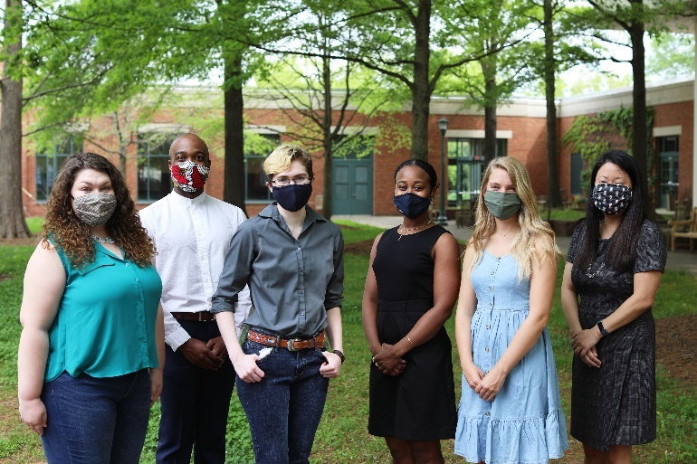

The Holistic Juvenile Defense Clinic, launched Spring 2021, represented more than a dozen young clients on both felony and misdemeanor charges in the clinic’s inaugural semester last spring, and with great success, according to clinic leaders.

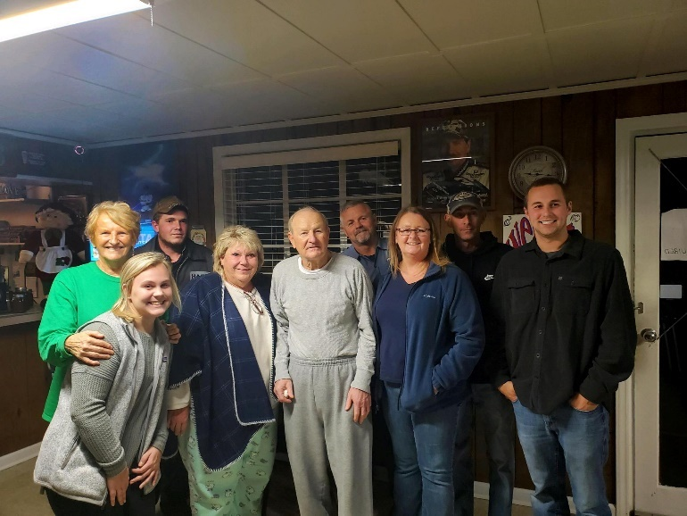

In Fall 2021, the Community Solutions Clinic debuted with projects geared toward problem solving around equity gaps in the Charlottesville area, and UVA clinic students attended a new three-part Orientation to Charlottesville series on community inequities, UVA’s relationship to the community, and local organizing efforts.

In Spring 2022, UVA Law will launch the Project for Informed Reform. The clinic allows students to research and investigate issues relating to criminal justice, and then generate evidence-based data and policy recommendations.

Also launching in the Spring, the Decarceration and Community Reentry Clinic, will be focused on transitioning the formerly incarcerated to new lives. The clinic will be led by Kelly Orians, who recently served as co-director of The First 72+, an organization that helps formerly incarcerated people support each other on the path to receiving services, finding work and preventing reincarceration.
“For some of their clients, students were in text groups with the legislators during the legislative committee hearings, sharing information and advice in real-time as questions came up,” Block said.

University of Washington School of Law
We are excited to introduce you to our newest colleague at the University of Washington School of Law, David B. Owens. David will teach our new Civil Rights and Justice Clinic (CRJC), focused on issues of constitutional rights, race, and criminal justice. The mission of the Civil Rights and Justice Clinic (CRJC) is to address the violation of people’s rights, to confront racial and social inequity, and to pursue measures of accountability and reform that will prevent and deter wrongs in the future. To do so, the CRJC involves three principal components: (1) litigation—representing people, and classes of people, who have been abused or harmed by the police or other public officials in civil rights actions pursuant to 42 U.S.C. § 1983, Washington’ Wrongly Convicted People Act, RCW 4.100 et seq, and other statutes; (2) community collaboration and policy work—collaborating in non-litigation, community-driven initiatives the improve policy, practice, and legislative efforts seeking to reform and that address race, accountability, transparency, policing, and criminal justice; and (3) research and impact advocacy—engaging in research and advocacy to address systemic issues.

UW Law School’s Mediation Clinic collaborated with two local non-profits, the King County Dispute Resolution Center and Housing Connector and was awarded a $225,000 grant by the Seattle Housing Authority to design and implement a pilot project aimed at eviction prevention. Grounded in an understanding of both tenant advocacy and housing management, the pilot project will offer communications coaching, conciliation, skilled negotiation, facilitation, mediation, and the integration of social services support to maximize compassionate, practical solutions to housing conflict.

Wake Forest University School of Law
The school added two new clinics in the fall of 2021. Professor Zaneta Robinson joined the Wake Forest Law faculty as the founding director of the Intellectual Property Clinic and Professor Allyson Gold joined Wake Forest Law as director of the school’s new Medical-Legal Partnership Clinic. These clinics contribute to Wake Forest’s longstanding commitment to experiential education and existing clinical offerings: Innocence & Justice Clinic; Appellate Advocacy Clinic; Veterans Legal Clinic; Environmental Law & Policy Clinic; and Community & Business Law Clinic.

To facilitate cross-clinic collaboration, Wake Forest Law created a new suite and workspace to house its six clinics. This has allowed our clinical program to leverage our faculty’s expertise and shared resources. Building on our strong pedagogical foundation, the clinical program continues to expand interprofessional learning opportunities for students through collaboration with the Wake Forest School of Medicine, School of Business, Department of Spanish, Journalism Program, Office of Sustainability, Department of Counseling, and School of Divinity, among others. In addition to providing our students with a foundation in interprofessional collaboration, our partnerships contribute to the clinical program’s multifaceted approach to addressing clients' legal needs.

Washington and Lee University School of Law
W&L Law’s newest clinic, the Civil Rights and Racial Justice Clinic (CRRJC), began operations this fall, under the direction of our newly-hired Assistant Clinical Professor Carla Laroche. With critical race theory as its foundation, students in CRRJC provide direct legal representation in housing and employment matters, develop and conduct know-your-rights workshops, and engage in strategic policy advocacy and reform grounded in the needs of the community. As a way of empowering tenants facing eviction, CRRJC has offered legal advice to tenants with landlord tenant matters in the Roanoke City General District Courthouse weekly since October.

The CRRJC replaces our death penalty clinic, the Virginia Capital Case Clearinghouse (VC3), which opened in 1988. VC3 assisted lawyers in pre-trial state capital cases throughout Virginia and, later, represented parole-eligible inmates across Virginia in their applications for parole. With the retirement of Professor David Bruck in 2020 and the legislative abolition of capital punishment in Virginia in 2021, the faculty decided that the creation of the CRRJC was an appropriate next
chapter and fitting tribute to the work of VC3 over the past several decades.

Washington University School of Law
The Interdisciplinary Environmental Clinic, in partnership with local neighborhood
associations and Legal Services, has been fighting to reduce vacancy in St. Louis’ impoverished neighborhoods in pursuit of environmental justice. Using legal demands and lawsuits, the clinic has facilitated the transfer of nuisance properties into the hands of responsible parties who will remedy nuisance conditions and make the properties habitable.

Students in the First Amendment Clinic (FAC) defeated attempts to close a hearing and seal documents in a lawsuit involving the death of Tory Sanders, a young man suffering from mental illness in a rural Missouri jail. The case was of significant public interest and the subject of two Missouri Attorney General investigations. The FAC’s motion to intervene and opposition to sealing filed on behalf of the St. Louis Post-Dispatch allowed the newspaper to report on the details of an agreement to settle the wrongful death claims against Charleston, MO.

The Civil Rights & Mediation Clinic has developed an innovative program for providing mediations in the community prior to the filing of eviction and foreclosure lawsuits. The Clinic has generated significant buy-in from landlords, tenants, mortgagors, mortgagees, and volunteer mediators in support of this important initiative. For more information,see https://www.stlmediationproject.org .

Students in the Entrepreneurial and Intellectual Property Clinic provided drop-in office hours for participants in a local accelerator that supports Black and Latinx entrepreneurs. In addition to legal assistance, entrepreneurs had access to grant resources, business coaching, and mental health support. The program seeks to support businesses that will create living-wage jobs for community-members living in poverty.

West Virginia University College of Law
The WVU Clinical Law Program has hired its first social work graduate student to work alongside student attorneys and with clients. The student, who is earning her MSW from WVU, serves the clinic’s clients holistically, including connecting them to resources to improve their quality of life. She also consults with law students on topics such as communication and stressors in their relationships with clients.

WVU Law’s Veterans Advocacy Law Clinic recently held a legal services day for veterans and their families in Charleston, West Virginia. Student attorneys in the clinic provided free legal advice and services related to Veterans Affairs claims, wills and other issues. The Veterans Clinic opened a new regional office in Charleston in August.

The IRS awarded WVU Law $100,000 to convert its Taxpayer Advocacy Law Clinic into the only Low Income Taxpayer Clinic in West Virginia. The grant will help fund a new full-time program director, and the clinic will be renamed the WVU College of Law Low Income Taxpayer Clinic.

Committee Announcements

Communications Committee
The Communications Committee works to ensure that law school clinical programs have opportunities to share news with one another, through our twice annual publication of this Newsletter, and that the other modes of sharing and receiving information, such as via website and listservs, are robust and accessible by all Section members. We are currently seeking to understand the multitude of topical listservs that exist for clinical professors. If you haven’t already communicated to Professor Kim Ambrose about your listserv and how to join, please email her at kambrose@uw.edu. Also, if your committee or regional conference needs additional communications support, please let us know by emailing Professor Gail Silverstein at silverst@uchastings.edu. Finally, because we have sustainable terms of membership and welcome new voices, the Committee will be seeking three new members to start next summer, including one person to help edit our newsletter. If you are interested, please also contact Gail Silverstein.

Externship Committee
Our wonderful subcommittees engaged in their own reflection and collaboration this summer. As a result, they created a robust lineup for our fall sessions, which included multiple structured and informal spaces to learn.

The Membership committee hosted Recess on the last Thursday of September and October. These informal gatherings provided a chance to connect with other externship folks, ask questions, share experiences, and discuss topics important to our work.

The Anti-Racism Think Tank hosted four Sharing Spaces, which were inspired by their work with a call for more space to organically share difficult moments in teaching. The unstructured but sacred space provided an opportunity for professors to come together and discuss a challenge and collectively brainstorm ideas to assist. Each session was facilitated by a Think Tank Committee member who helped guide the conversation and ensure the mission is focused on the work to create equity.

Each subcommittee also engaged our community in timely discussions with dynamic speakers. Our Membership subcommittee welcomed us Forward into the New World in August. We explored Around the
World Teaching Cultural Humility with our International and Away Externships subcommittee in October. Our Teaching Methodologies subcommittee provided valuable tools on teaching our students how to interpret, receive, and integrate Feedback. To finish up the semester, our Anti-Racism Think Tank helped us process our design choices around Racial Justice Pedagogy.

We are extremely grateful to all the organizers, speakers, and participants who made it possible to sustain our growth, energy, and creativity this fall semester.

Please feel free to contact the chairs, Nira Geevargis at geevargis@uchastings.edu and Amanda Riva at arivas@stmarytx.edu.

International Committee
In October 2021, International Committee held, “Lightning Rounds on Teaching Cultural Humility Around the World.” Clinical colleagues from India (2), Nigeria (2), Indonesia, Pakistan, Russia and the United States presented on how they are addressing the topic of cultural humility within their own clinical programs. It was an energizing and inspiring presentation, and the Committee is working to plan one more zoom session with our global colleagues at a time that will be convenient to different time zones. This builds on the Committee’s longstanding commitment to engaging with our clinical colleagues from outside the United States in shared learning spaces, and we look forward to continuing these discussions on topics that resonate in clinical programs around the world. If you are interested in being a part of these discussions, or in contributing in any way to the International Committee, please email the Committee co-chairs, Sarah Paoletti at paoletti@law.upenn.edu, Gilian Dutton at duttong@seattleu.edu, and Susan Felstiner at sfelstiner@lclark.edu.

Policy Committee
We recently published work on two joint projects with the Clinical Legal Education Association (CLEA) Committee on Faculty Equity and Inclusion. First, the Committee’s report Clinicians Reflect on COVID-19: Lessons Learned and Looking Beyond was published in the special edition of the Clinical Law Review, 2020 Hindsight: Reflections on the Pandemic, Protests, and Political Perils. The report shares the responses of 220 clinicians surveyed on their experiences adapting their legal advocacy and teaching, as well as their institution’s treatment of clinics and clinicians, during the first phase of the pandemic. The report recommends actions law schools can take to equip themselves to provide appropriate support for clinical faculty during future emergencies, emphasizing the importance of providing institution-wide resources while balancing autonomy and discretion for clinicians; special attention to diverse and vulnerable clinicians; and accommodating the very serious legal and ethical obligations of clinical law practice.

Second, the Committee published a guide on Best Practices for Hiring and Retention of Diverse Clinical Faculty with strategies for law school administrators and hiring decision-makers to consider in their efforts to improve diversity on the school’s clinical faculty. Adapted from existing diversity publications, the guide includes practical suggestions on every phase of the hiring process from job posting to finalist interviews and offers, as well as considerations for inclusion to encourage faculty to stay and thrive long-term at institutions.

https://www.dropbox.com/s/4ww2ldydp1wy4sd/Diversity%20Best%20Practices%20Final.pdf?dl=0 Please contact Kele Stewart for any questions about the committee.kstewart@law.miami.edu>

Honors, Accolades and Victories

The Florida State University Children in Prison Project, directed by Prof. Paolo Annino, had a major victory! Kenneth Young was 15 years old when he received four consecutive life without parole sentences. The Children in Prison Project has been advocating for Kenneth for 12 years. A documentary entitled 15-to-Life memorializes Kenneth’s Story. Kenneth was released from prison on July 1, 2021.
Fordham Law and the Fair Consumer Judgment Interest Rate Bill – Students in the Legislative and Policy Advocacy Clinic under the direction of Elizabeth Cooper, in coalition with the Feerick Center for Social Justice, were key players in successfully urging the New York State Assembly and Senate to pass the Fair Consumer Interest Rate Bill. This bill would reduce the statutory interest rate in New York in court-ordered, consumer debt judgments from 9% to 2%.
In September, the Center for Health Law and Policy Innovation’s (CHLPI’s) litigation program at Harvard Law School celebrated major wins in the courts for the rights of transgender and gender nonconforming people. Favorable decisions were made on two cases in which CHLPI submitted amicus briefs supporting plaintiffs: 1) Kadel v. North Carolina State Health Plan for Teachers & State Employees, co-authored with Professor Kevin Barry of Quinnipiac Law School, and 2) Shorter v. United States of America, co-authored with Harvard Law School’s LGBTQ+ Advocacy Clinic.

In June 2021, SMU Dedman School of Law’s COVID-19 Legal Helpline, a project of the Civil Clinic, received the 2021 State Bar of Texas W. Frank Newton Award for its exceptional dedication to legal services for low-income North Texans. The award recognizes individuals and groups whose work exemplifies a deep commitment to pro bono service. The Civil Clinic is also piloting a collaboration with the Child Poverty Action Lab (CPAL) to conduct court observations in Dallas County eviction court that will explore the impact of eviction on children, with the aim of eventually expanding the project throughout the county and working with CPAL to advocate on behalf of tenants and their families.

The University of Baltimore Innocence Project Clinic was honored by the Judge Alexander Williams, Jr. Center for its commitment to criminal justice reform at the third annual Judge Alexander Williams Lecture on November 11, 2021. On November 4, 2021, David Morris, a UB Innocence Project client, was exonerated after serving 17 years for a Baltimore City murder that he did not commit. This exoneration was the result of the collaboration of the UBalt Innocence Project Clinic, the Mid Atlantic Innocence Project, and the Conviction Integrity Unit of the Baltimore City State's Attorney's Office. The exoneration was featured in many news outlets, including CNN. https://www.cnn.com/2021/11/04/us/david-morris-exonerated-maryland-prison/index.html
The University of Tennessee Legal Clinic received an additional $100,000 grant to fund our Reentry Fellow, Karla Mendez, and the development of ExpugeTN.org. ExpungeTN.org, a statewide website that we aim to launch next semester, will help individuals with criminal records expunge eligible criminal charges, restore their voting rights, and draft court documents.

The clinic received a new $3000 Diversity Challenge Grant from the University to support its Racial Justice Listening Project. RJLP was launched to build our understanding of how local community leaders are trying to confront structural racism and then to marshal our transactional and litigation legal clinic resources towards their goals. The clinic faculty under the leadership of Wendy Bach designed and implemented a qualitative research study with IRB approval to conduct interviews with community leaders and developed a three-credit course to engage students in RJLP’s work. We are beginning to use the results of the study to reimagine the work of each individual clinic.

A client of the West Virginia Innocence Project Law Clinic at WVU Law was exonerated of murder after DNA evidence identified the actual perpetrator. The DNA had been retrieved from the 2002 crime scene but had not been presented at the original trial in 2008. Two other clients in the case, also exonerated, were represented by the University of Chicago Law School’s Exoneration Project and the national Innocence Project. A judge overturned the murder convictions in 2019.

Upcoming Meetings and Conferences

The UBalt Center on Applied Feminism is hosting its 13th Annual Feminist Legal Theory Conference, Applied Feminism & The Big Idea April 7-8, 2022. This year, the conference aims to capture, develop, and disseminate cutting edge theorizing around issues of gender equity and intersectionality. We are in a tumultuous period of history in which we are grappling with a global health pandemic and sharp political polarization, while also experiencing flourishing movements for racial and gender justice. This is a time for innovation and creativity — for highlighting ideas that create a more just society. We will be exploring how feminist legal theory is responding and growing during this time and bridging toward a future of greater gender and intersectional justice. We hope you will join us for this conference.

University of Miami

February 19, 2022 – University of Miami School of Law will host this year’s International Human Rights Clinician Conference.

March 31, 2022 – Professor Harold Koh will be the speaker at the University of Miami School of Law annual Henkin Lecture on Human Rights. For more information, see https://www.law.miami.edu/academics/human-rights-law-program-events

April 21, 2022 – Gender Justice and Human Rights Symposium: Holistic Approaches to Gender Violence. For more information and to register, see https://www.law.miami.edu/academics/human-rights-law-program-events

Externships 11 – UCLA and Pepperdine, October 2022

Thank you for bearing with us as we took stock and adjusted our plans in light of the Delta surge. The Externships 11 Committee is proud to announce that we will host the next Externships Conference on October 7-9, 2022 in Southern California. Please save the date!

In light of the postponement, we will also be extending the deadline for submitting RFPs. RFPs will be due on March 14, and can be submitted via this google form (https://forms.gle/JKAhq3UubJjdqyFA9)

If you would like to present, but you have a half-baked or not-at-all baked idea, please consider filling out our RFP Interest form (https://forms.gle/w6UExwP5aERqVhb38) by January 14. A committee member will be in touch to discuss your interest.

We look forward to working with possible presenters, and to seeing all of you next fall in sunny California!

